# Virtual screening by Molecular docking of anti_cancer activity within turmeric phytochemicals compounds that target MetAP2 on patients with liver cancer

## Introduction:

Liver cancer, particularly hepatocellular carcinoma (HCC), poses a significant global health burden. It is the third leading cause of cancer-related deaths worldwide This aggressive malignancy demands the exploration of novel therapeutic strategies. Here, we focus on the interplay between Methionine aminopeptidase 2 (MetAP2) and turmeric’s phytochemicals compounds in the context of HCC.

MetAP2, a protein involved in newly synthesized protein processing it catalyzes the hydrolytic cleavage of the N-terminal methionine, MetAP2 has emerged as a potential target in cancer progression due to its association with angiogenesis, cell proliferation, and poor unfavorable prognosis in HCC patients.

Turmeric (Curcuma longa), has garnered considerable interest for its anti-cancer properties. Studies suggest its ability to inhibit cancer cell growth and proliferation while promoting apoptosis (programmed cell death).

## Phytochemicals libraries:

A library of 51 phytochemicals from turmeric was curated. These compounds included curcumin, demethoxycurcumin, and zingiberene, along with other terpenes and sesquiterpenes. All these were documented with their chemical name, structure in SDF format, and source—PubChem CID, scientific references to source. This phytochemical library would be useful in the next step of molecular docking by providing a set of compounds with their structures for interaction analysis .

## Protein Preparation:

A protein structure with PDB ID 1R58, which corresponds to Methionine Aminopeptidase 2 (MetAP2), was selected as the target for docking analysis. Cleaning of the protein structure was done using PyMOL by removing water molecules comprising 416 atoms together with bound ligands/hetero atoms comprising 25 atoms. Hydrogens were thereafter added to the structure because accurate protein-ligand interactions depend on hydrogens during docking. Charges were finally added to the protein with the help of tools available in PyMOL to ensure proper molecular interactions. This step ensured that the protein structure was optimized for the docking process by being free from unnecessary components and chemically complete.

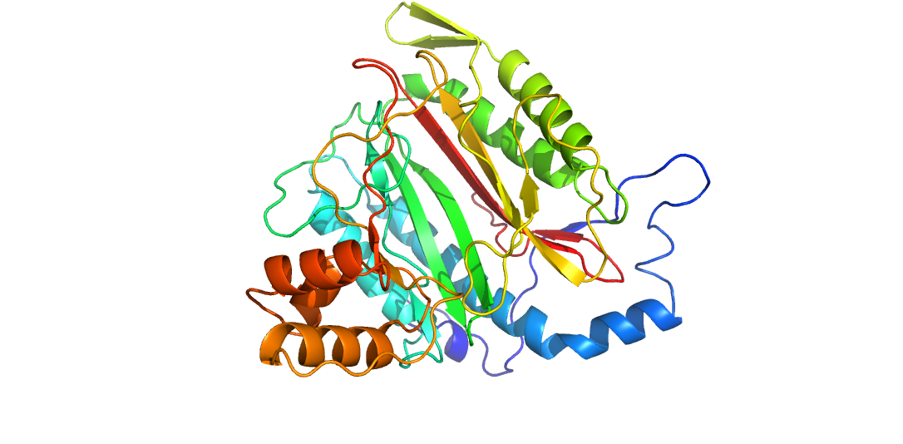

**Figure 1 : Visulization of the prepared protein.**

## Molecular Docking of Turmeric Compounds against MetAP2:

CASTp was used to obtain active sites for MetAP2. The energy minimization of the 51 curated turmeric compounds was done using PyRx , after which structures of protein and ligand were converted to the pdbqt format for docking. Simulations of docking were conducted with the aid of a grid box laid over the active site, creating multiple binding modes for each ligand. The binding affinity analysis revealed six turmeric compounds with the top binding affinities to MetAP2: Cyclocurcumin Model 1 (-8.9 kcal/mol), Curcumol Model 1 (-8.6 kcal/mol), Cyclocurcumin Model 2 (-8.6 kcal/mol), Cyclocurcumin Model 3 (-8.5 kcal/mol), Tetrahydrocurcumin Model 1 (-8.3 kcal/mol), and Demethoxycurcumin Model 1 (-8.1 kcal/mol).

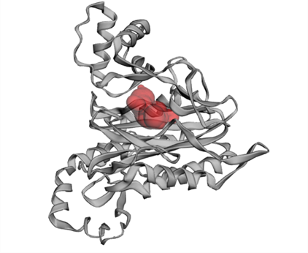

## **Crystal Structure of MetAP2 complexed with A357300 showing the most active pocket**

## 

## 

## 

## Visualizations of the six models with the highest binding affinity:

The binding modes of the top compounds with the highest affinities were visualized using Pymol to gain insights into their interactions within the active site of MetAP2

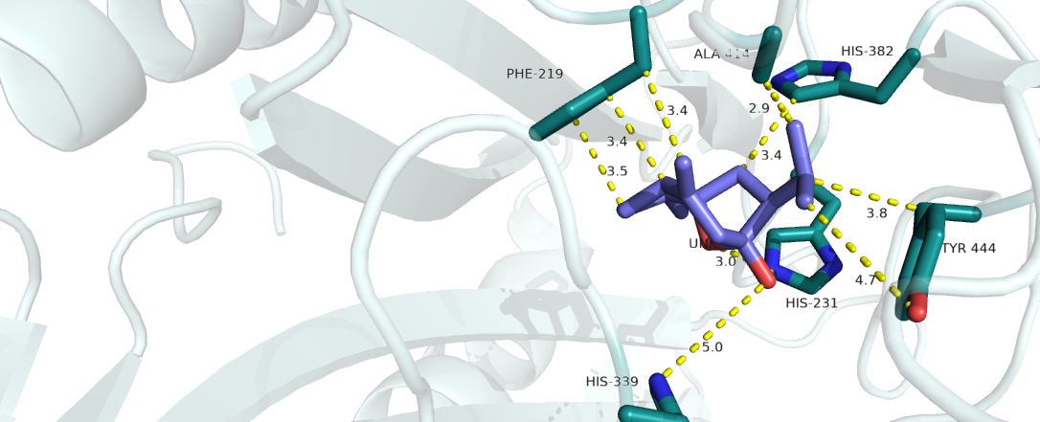**Figure 2: Curcumol model 1(deepblue) on the protein binding site (AA residue on green).**

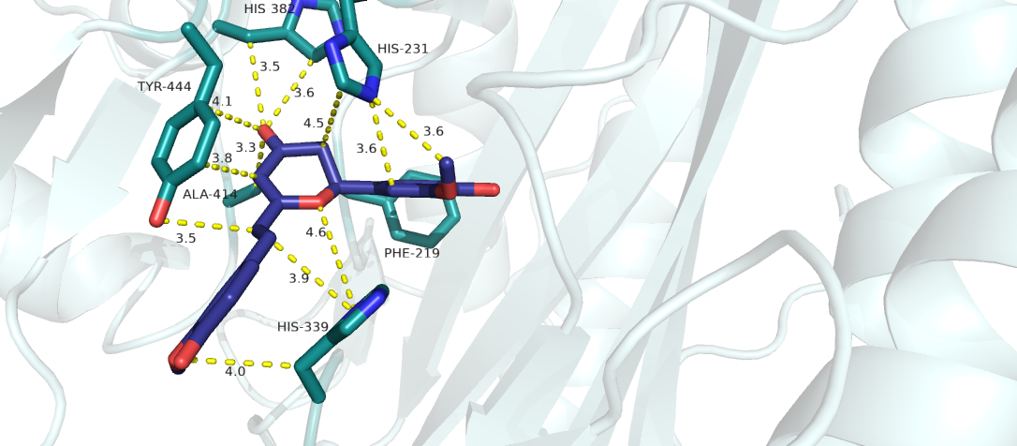

**Figure 3 : Cyclocurcumin model 1 ( deepblue ) on the binding site.**

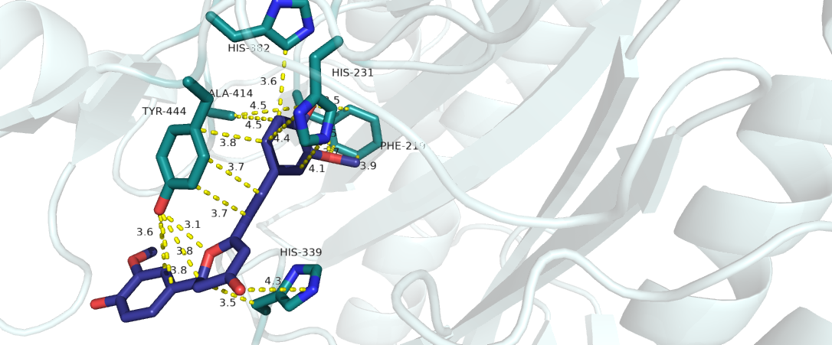

**Figure 4 : Cyclocurcumin model 2 ( deepblue ) on the binding site .**

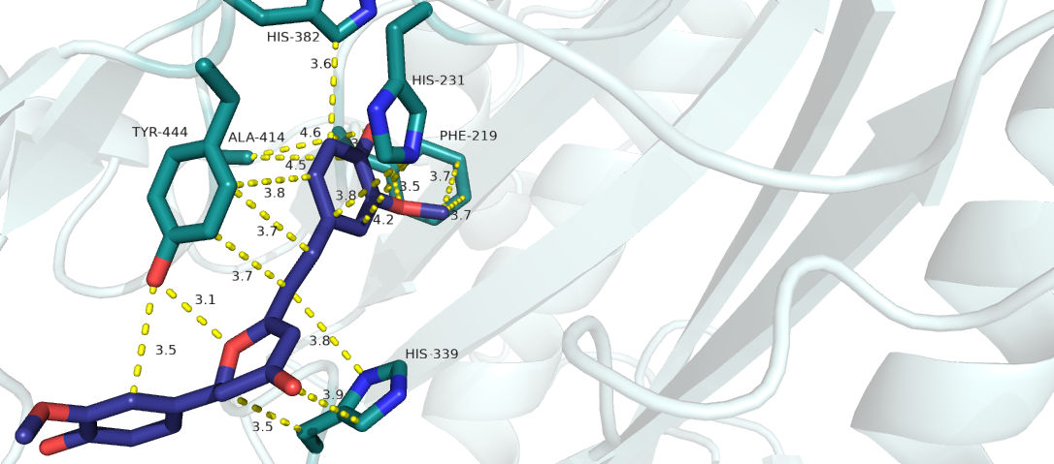

**Figure 5 : Cyclocurcumin model 3 (deepblue) on the binding site .**

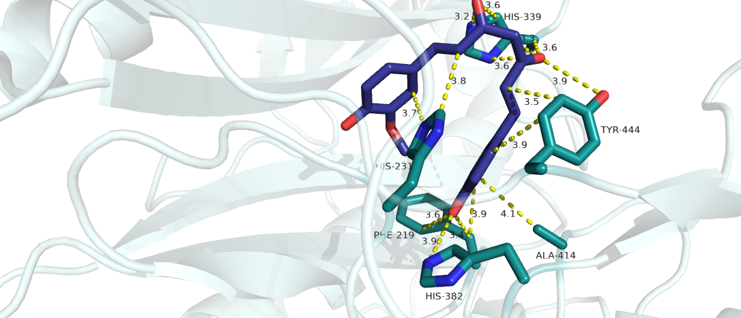

**Figure 6: Demethoxycurcumin model 1( deepblue ) on the binding site.**

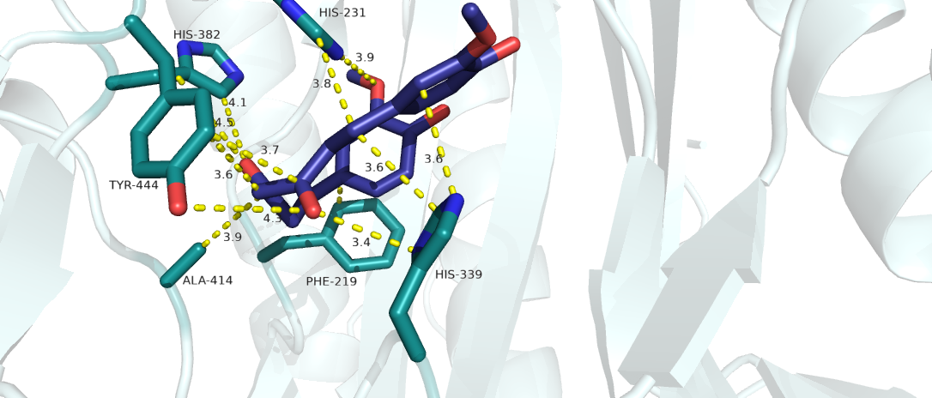

**Figure 7 : Tetrahydrocurcumin model 1 (deepblue) on the binding site .**

## Conculations:

This study identified several turmeric-derived compounds, particularly cyclocurcumin and curcumol, as having strong binding affinity for MetAP2, indicative of good pharmacological candidates against MetAP2-related diseases. This study not only provided potential lead compounds for drug development but also established a reusable pipeline for protein-ligand docking analysis that could be applied in future therapeutic research.

**________________________________________**

## References :

1- Asafo-Agyei KO, Samant H. Hepatocellular Carcinoma. [Updated 2023 Jun 12]. In: StatPearls [Internet]. Treasure Island (FL): StatPearls Publishing; 2024 Jan-. Available from: <https://www.ncbi.nlm.nih.gov/books/NBK559177/>

2- Dallakyan, S., & Olson, A. J. (2015). Small-molecule library screening by docking with PyRx. *Chemical Biology*, *1263*, 243–250. https://doi.org/10.1007/978-1-4939-2269-7_19

3- Jiang, Y., Hui, D., Pan, Z. *et al.* Curcumin promotes ferroptosis in hepatocellular carcinoma via upregulation of ACSL4. *J Cancer Res Clin Oncol* **150**, 429 (2024). <https://doi.org/10.1007/s00432-024-05878-0>

4- Kim, S., Chen, J., Cheng, T., Gindulyte, A., He, J., He, S., ... & Bolton, E. E. (2016). PubChem Substance and Compound databases. *Nucleic Acids Research*, *44*(D1), D1202–D1213. https://doi.org/10.1093/nar/gkv951

5- Li W, Zhou Y, Yang J, Li H, Zhang H and Zheng P: Curcumin induces apoptotic cell death and protective autophagy in human gastric cancer cells. Oncol Rep 37: 3459-3466, 2017.

6- Li, Y., Sun, W., Han, N. *et al.* RETRACTED ARTICLE: Curcumin inhibits proliferation, migration, invasion and promotes apoptosis of retinoblastoma cell lines through modulation of miR-99a and JAK/STAT pathway. *BMC Cancer* 18, 1230 (2018). <https://doi.org/10.1186/s12885-018-5130-y>

7- National Cancer Institute. (n.d.). What is liver cancer? <https://www.cancer.gov/types/liver/what-is-liver-cancer>

8- Schrödinger, LLC. (2015). The PyMOL Molecular Graphics System, Version 1.8. https://pymol.org/2/

9- Sheppard, G. S., Wang, J., Kawai, M., BaMaung, N. Y., Craig, R. A., Erickson, S. A., Lynch, L., Patel, J., Yang, F., Searle, X. B., Lou, P., Park, C., Kim, K. H., Henkin, J., Lesniewski, R.(2004). 3-Amino-2-hydroxyamides and related compounds as inhibitors of methionine aminopeptidase-2. Bioorganic & Medicinal Chemistry Letters, 14(4), 865-868. doi:10.1016/j.bmcl.2003.12.031.

10- Tian, W., Chen, C., Lei, X., Zhao, J., & Liang, J. (2018). CASTp 3.0: computed atlas of surface topography of proteins. *Nucleic Acids Research*, *46*(W1), W363-W367. <https://doi.org/10.1093/nar/gky473>

11- Wilken, R., Veena, M.S., Wang, M.B. *et al.* Curcumin: A review of anti-cancer properties and therapeutic activity in head and neck squamous cell carcinoma. *Mol Cancer* 10, 12 (2011). <https://doi.org/10.1186/1476-4598-10-12>

12- Xiao Q, Zhang F, Nacev BA, Liu JO, Pei D. Protein N-terminal processing: substrate specificity of Escherichia coli and human methionine aminopeptidases. Biochemistry. 2010 Jul 6;49(26):5588-99. doi: 10.1021/bi1005464. PMID: 20521764; PMCID: PMC2906754.

13- Yoysungnoen P, Wirachwong P, Changtam C, Suksamrarn A, Patumraj S. Anti-cancer and anti-angiogenic effects of curcumin and tetrahydrocurcumin on implanted hepatocellular carcinoma in nude mice. World J Gastroenterol 2008; 14(13): 2003-2009 [PMID: 18395899 DOI: 10.3748/wjg.14.2003].

## Attached files :

1- the prepared protein pdb file.

2- the binding side measurements.

3- the phytochemicals libraries table and SDF structures files

4- the docking result file .